CAPABILITY STATEMENT OVERVIEW

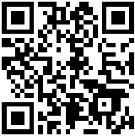

Specialty Cable Corporation

2 Tower Drive

Wallingford, CT 06492

**Contacts:**

Kim Bowen CEO kbowen@specialtycable.com

James Streifel Sales jstreifel@specialtycable.com

Ken Caplet Quality kcaplet@specialtycable.com

Phone: 203-265-7126

Fax: 203-269-5293

[www.specialtycable.com](http://www.specialtycable.com)

CAGE CODE: 60685

D&B: 16-1333141

EIN: 06-1184041

NAICS: 335929

336412, 334419

331318, 331420

PSC: 6145

**CERTIFICATES:**

AS9100C CERT#0033461

ISO 9001-2008

JCP DLIS 006506

Certified Small Business

Accepts Credit Cards

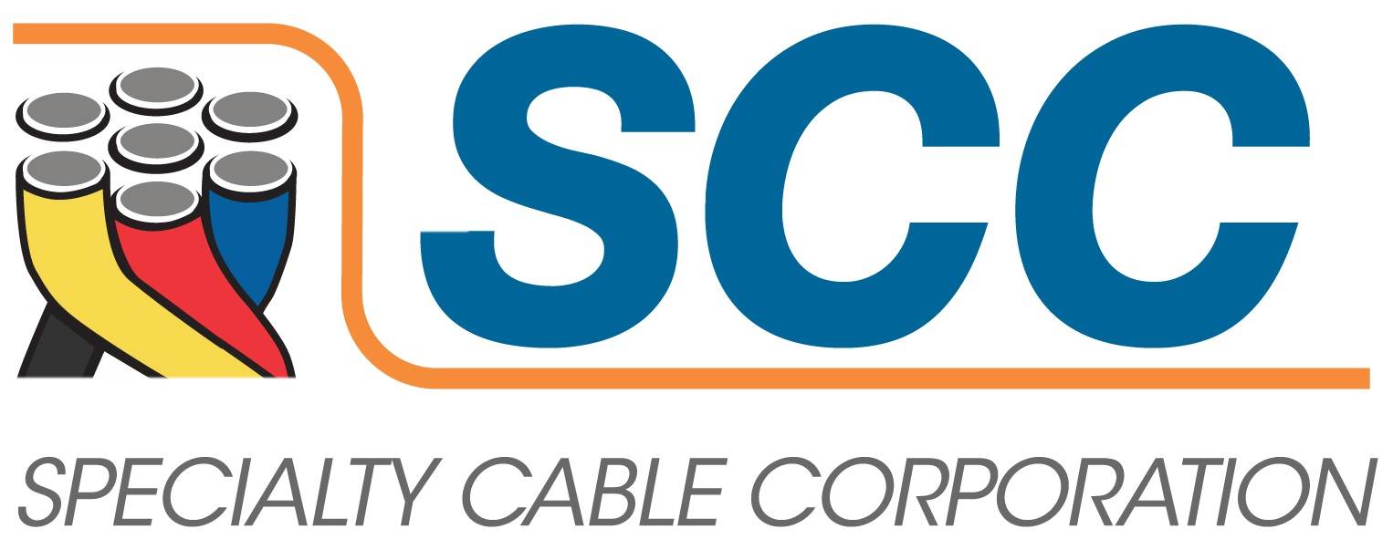**Precision**

When lives are on the line... Precision is a ***way of life.***

**Company Overview**

Specialty Cable Corporation (SCC) began producing highly engineered wire and cable products for military and aerospace applications in 1942.  Our foundation was based on innovation and the ability to produce to the most exacting specifications for these critical applications. It has served SCC well and fueled our growth.

Today that same foundation continues to drive innovation and quality at SCC. It has resulted in proprietary manufacturing methods providing unique product enhancements only available from us.  It produces some of the most advanced interconnect products for an increasing number of industries. We engineer and construct high-quality wire and cable in our modern facility. Our engineering expertise and broad manufacturing capabilities enable us to produce cables for exacting specifications, hostile environments, extreme temperatures and other demanding applications.

We are proud of the quality of our products. Our innovative solutions and reputation for quality has helped us to build strong and lasting partnerships with our customers. We are committed to continuous improvement and maintain certification to the requirements of **AS9100C and ISO 9001:2008.**

**Industries Served:**

**Aerospace (Military and Commercial)**

**Medical (High Temperature and Low Temperature)**

**Industrial & Energy**

**Heater Cables**

**Commercial (UL/CSA)**

**Mil-spec qualifications: M25038/1, M25308/3, M5086/2, M22759/1 through 12 and M22759/22 & 23, M27500 high temperature cables (various styles), M5846 thermocouple cables and customer specific flight critical cables.**

